

CIS120A: Network Security, Part 1
Lab Manual

Table of Contents

Week 1 3
Exercise 1: Discovering Nmap 4
Exercise 2: Advanced NMAP 7
Week 2 12
Exercise 3: Digital Certificates 13
Exercise 4: Understanding Nessus 17
Week 3 24
Exercise 5: SQL Injection & Beyond 25
Week 4 28
Exercise 7: Authenticating Authentications 29
Exercise 8: Password Policy & DAC 35
Week 5 40
Exercise 9: Mobile Device Hardening (for Android) 41
Exercise 9: Mobile Device Hardening (for Apple iOS) 57
Exercise 10: Hardening the host 72

Week 1

Exercise 1: Discovering Nmap 4
Exercise 2: Advanced NMAP 7

Exercise 1: Discovering Nmap
Learning Objectives:
- CO 1.7 Summarize the techniques used in security assessments.
- CO 1.8 Explain the techniques used in penetration testing.
- CO 4.1 Given a scenario use the appropriate tool to assess organizational security.
Estimated time to Complete: 1 hour 30 minutes

Description:
The purpose of this lab is to gain practical experience and to build real-world network security
skills with Nmap, a network mapping tool.

Required Resources:
• A working PC with Windows 10 or better installed.
• Your home network will be used.
• NMAP software

Deliverable:
Answer each of the questions in this manual, then transfer your answers to the item “Week 1:
Hands-on exercise 1 – Discovering Nmap Grade Sheet” in Canvas.
Setup:
Acquire a working PC with Windows 7 or newer with NMAP installed.
NMAP may be downloaded from nmap.org, download the latest stable version applicable to your operation system.

Lab Steps:

1. Open a terminal (AKA command prompt/run).
2. At the terminal prompt, enter nmap and press ENTER.
What categories are available?
______________________________________________________________________________
______________________________________________________________________________
______________________________________________________________________________
What does the -sL switch do?
______________________________________________________________________________
Scan Your Localhost
1. Enter nmap -A -T4 localhost
Was a SYN Stealth Scan performed? Why or why not?
______________________________________________________________________________
______________________________________________________________________________
Scan Your Network
1. Find out what your IP address and the subnet mask are. Type ipconfig.
Record your IP address and subnet mask?
______________________________________________________________________________
2. Look for other hosts on this network. Type nmap -A -T4 (network address/cidr).
How many hosts are up?
______________________________________________________________________________

List at least 3 IP addresses of the hosts that are on the same LAN as your computer. List some
of the services that you see on those hosts.
______________________________________________________________________________
______________________________________________________________________________
______________________________________________________________________________
Scan a Remote Server
1. Scanme.nmap.org is a free service that Nmap has for you to safely scan an external
target.
DO NOT SCAN ANY OUTSIDE NETWORK WITHOUT PRIOR WRITTEN APPROVAL FROM
THE OWNER!!!
Type nmap -A -T4 scanme.nmap.org.
What ports and services are opened?
______________________________________________________________________________
______________________________________________________________________________
What ports and services are filtered?
______________________________________________________________________________
______________________________________________________________________________
What is the IP address of the server?
______________________________________________________________________________
What is the operating system?
______________________________________________________________________________
2. Type exit to close the terminal.

Summary

Nmap is a powerful tool used to explore and manage networks.
How can Nmap be used to help with network security?
______________________________________________________________________________
______________________________________________________________________________
______________________________________________________________________________
How can Nmap be used by threat actors?
______________________________________________________________________________
______________________________________________________________________________
______________________________________________________________________________
Why should you NOT scan any outside networks without permission?
______________________________________________________________________________
______________________________________________________________________________
______________________________________________________________________________

Exercise 2: Advanced NMAP

Learning Objectives:
- CO 1.7 Summarize the techniques used in security assessments.
- CO 1.8 Explain the techniques used in penetration testing.
- CO 4.1 Given a scenario use the appropriate tool to assess organizational security.

Estimated time to Complete: 1 hour 30 minutes

Description:

The purpose of this lab is to gain practical experience and to build real-world network security skills with Nmap, a network mapping tool using more advanced attributes.

Required Resources:
- A working PC with Windows 10 or better installed.
- Your home network will be used.
- NMAP software

Deliverable:
Answer each of the questions in this manual, then transfer your answers to the item “Week 1 Hands On Exercise 2 - Advanced NMAP Grade Sheet” in Canvas.
Setup:
Login to a desktop or laptop computer with NAMP installed and execute a command line.

Lab Steps:
The usage of Nmap depends on the target machine because there is a difference between simple (basic) scanning and advance scanning. We need to use some advanced techniques to bypass the firewall and intrusion detection/preventative software to get the right result. Below are the examples of some basic commands and their usage:
If you want to scan a single system, then you can use a simple command
nmap target
# nmap website.com
If you want to scan the entire subnet, then the command is
nmap network/cdir
Please use this command on your network IP:
- Record your results
__ ___________________________________________
It is very easy to scan a multiple target, all you need to do is to separate each target via space:
nmap target target1 target2
Please use this command on your two IP addresses:
- Record your results
__ ___________________________________________

Let’s suppose you want to scan a range of IP addresses, but not the entire subnet. In this scenario, use this command:
nmap target-100
Please use this command,
- Record your results
____________________________________________
Let suppose you have a list of a target machines. You can make Nmap scan for the entire list:
Make a list of the IP addresses in file and save it under (target.txt) and implement the below command:
# nmap -iL target.txt . Make sure to put the file on the same directory,
- Record your results
__ ___________________________________________

If you want to see the list of all the hosts that you are scanning, then use the command with an -sL parameter:
nmap -sL target/cdir
Example: # nmap -sL 192.168.0.1/24
Please use this command:
- Record your results
__ ___________________________________________

In some cases we need to scan the entire subnet but not a specific IP addresses because it might be dangerous for us. In this scenario, use the Nmap command with the excluding parameter:
Example: # nmap 192.168.1.1/24 – -exclude 192.168.1.1
Please use this command on your IP addresses:
- Record your results
__ ___________________________________________

If you have a file that contains the list of IP addresses that you want to exclude, then you can call the file in the exclude parameter:
Example: # nmap 192.168.0.1/24 –exclude file target.txt
Please use this command:
- Record your results
___________________________________________

If you want to scan a specific port on the target machines (for example, if you want to scan the HTTP, FTP, and Telnet port only on the target computer), then you can use the Nmap command with the relevant parameter:
# nmap -p80,21,23 192.168.0.1 It scans the target for port number 80,21 and 23.
Please use this command on your IP:
- Record your results
__________________________________________

You now have a basic understanding of Nmap scanning techniques, but for the purposes of this article, we need to explore more in depth.

Notes:

Week 2

Exercise 3: Digital Certificates 13
Exercise 4: Understanding Nessus 17

Exercise 3: Digital Certificates

Learning Objectives:
- CO 2.8 Summarize the basics of cryptographic concepts.
- CO 3.1 Given a scenario, implement secure protocols.
Estimated time to Complete: 1 hour 30 minutes

Description:
The purpose of this lab is to gain practical experience and to build real-world network security skills with digital signatures and digital certificates.

Required Resources:
- A working PC with Windows 10 or better installed.
- Your home network will be used.
- Active Internet Connection

Deliverable:
Answer each of the questions in this manual, then transfer your answers to the item “Week 2: Hands On Exercise 1- Digital Certificates Grade Sheet” in Canvas.

Setup:
Login to a desktop or laptop computer running Windows 7 or above with internet access.

Lab Steps:

Digital Certificates

No | Description | Result
1 | Navigate to:  http://asecuritysite.com/encryption/digitalcert  Load certificate 1 and identify the following: | Serial number:  Effective date:  Name:  Issuer:  What is CN used for:  What is OU used for:  What is O used for:  What is L used for:
2 | Now open-up the ZIP file for the certificate and view the CER file. | What other information can you gain from the certificate:  What is the size of the public key:  Which hashing method has been used:  Is the certificate trusted on your system: [Yes][No]
3 | For Example 2 to Example 5. Complete the following table:

Cert | Organization  (Issued to) | Valid Date Range | Size of Public Key | Issuer | Root CA | Hash Method | Is it trusted?
2
3
4
5

*Note* Not all certificates will load on the website, some you will have to open yourself and view the information

PFX Files:

We have a root certificate authority of My Global Corp, which is based in Washington, US, and the administrator is admin@myglobalcorp.com and we are going to issue a certificate to My Little Corp, which is based in Glasgow, UK, and the administrator is admin@mylittlecorp.com.
No | Description | Result
1 | We will now view some PFX certificate files which are protected with a password.  Navigate to:  http://asecuritysite.com/encryption/digitalcert2 | For Certificate 1, can you open it in the Web browser with an incorrect password? Try any password:  Now enter “apples” as a password, and record some of the key details of the certificate:  Repeat for Certificate 2:
2 | Now with the PFX files (contained in the ZIP files from the Web site), try and import them onto your computer. Try to enter an incorrect password first and observe the message. | Was the import successful?  If successful, outline some of the details of the certificates:

Creating Certificates:

Now we are going to create our own self-signed certificate.

No | Description | Result
1 | Create your own certificate from:  http://asecuritysite.com/encryption/createcert  Add in your own personal details. | View the certificate and verify some of the details on it.  Can you view the DER file?
2 | Now download the certificate (CER) onto your Windows host and see if you can import it. | Did the certificate import successfully?  If so what are some of the details on the certificate? (Hint: certmgr)

Exercise 4: Understanding Nessus

Learning Objectives:
- CO 1.6 Explain the security concerns associated with various types of vulnerabilities.
- CO 1.8 Explain the techniques used in penetration testing.
Estimated time to Complete: 90 minutes
Description:
In this lab students will install or locate the program Nessus, on a Windows PC. The student will learn how to sniff the traffic being sent and received by the he most trusted vulnerability scanning platform used by auditors and security analysts.
Required Resources:
- A working PC with Windows 10 or better installed.
- Nessus program download, and registration with Tenable.
Deliverable:
Instructor will verify that lab is completed through a final screen or screenshot of the system scan results in Nessus. Answer each of the questions in this manual, then transfer your answers to the item “Week 2: Hands-on exercise 2 - Understanding Nessus Grade Sheet” in Canvas.
Setup:
A Microsoft Windows Machine with Windows 7, 8, or 10 operating system and a working Internet connection.

Lab Steps:
1. go to https://www.tenable.com/products/nessus/nessus-essentials

2. Register for an activation code using your name and school ciat.edu email.

3. Look for the email from Tenable. This will contain your activation code. Don't lose it.

4. Download the most current version of Nessus. Use the Windows Server 2008, Server 2008 R2*, Server 2012, Server 2012 R2, 7, 8, 10, Server 2016 (64-bit) version. If you have a 32-bit version of the Windows OS you can use the Windows 7, 8, 10 (32-bit) version.

5. Install the msi (executable) file that was downloaded using your web browser. You may need the instructor to provide credentials to install the program. (This may take 5 to 10 minutes to complete.)

6. Agree to the EULA and install default options. Include installing Win PCAP as well if asked.

7. A web browser should open to your local computer and warn you it is not secure. Bypass this by proceeding to the URL by using the Advanced option in Chrome, the More Information link in Internet Explorer, through "Details" and "Go on to webpage" links in Edge, or "Advanced" and "Except the Risk and Continue" in Firefox.

8. Login with the username and password you used at the Tenable site. It will install and compile items for Nessus to use. (This may take up 10 to 15 minutes.)
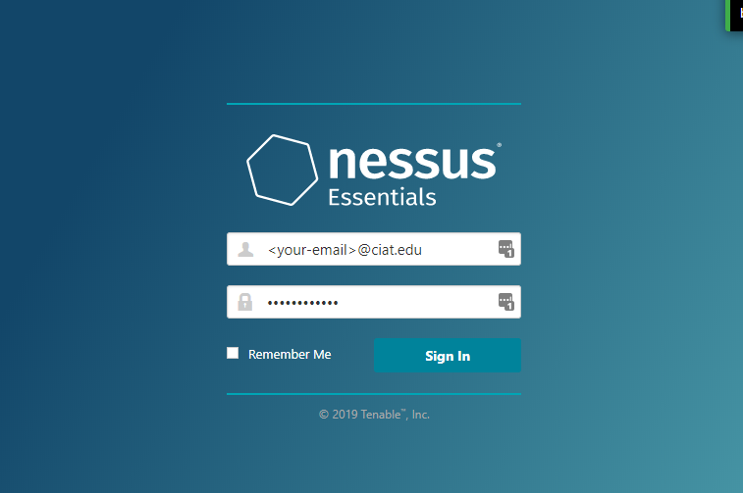

9. Find out your IP address by opening the cmd.exe or powershell.exe on the Windows machine.
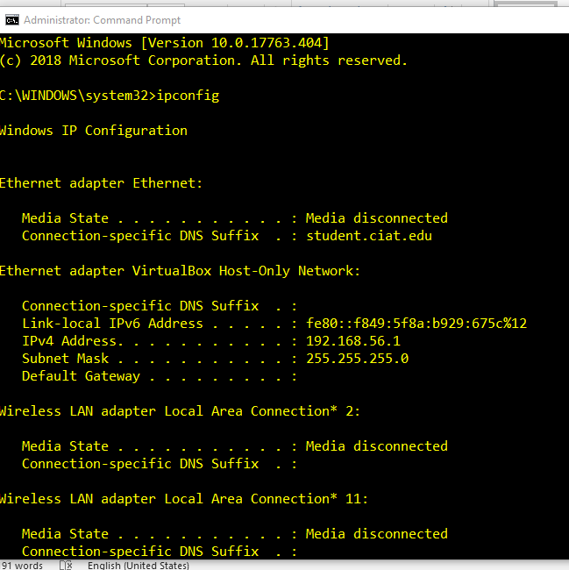

10. Once you have logged in, select the New Scan button in the Nessus web browser window.
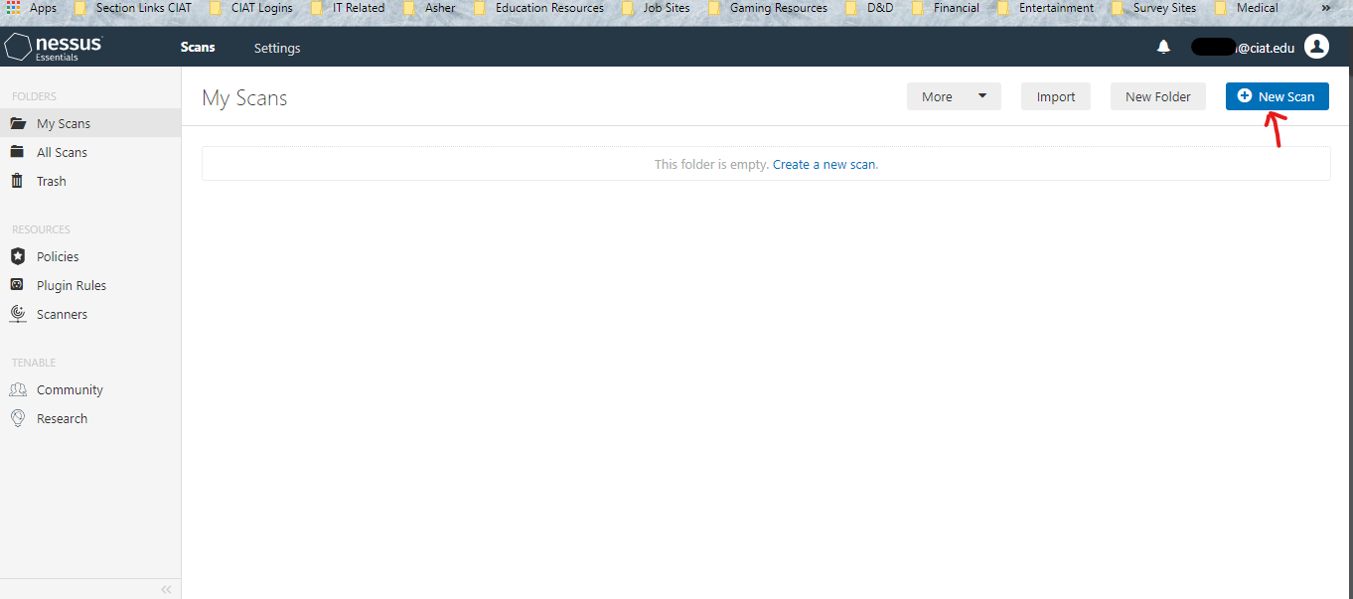

11. Select the Basic Network Scan option.
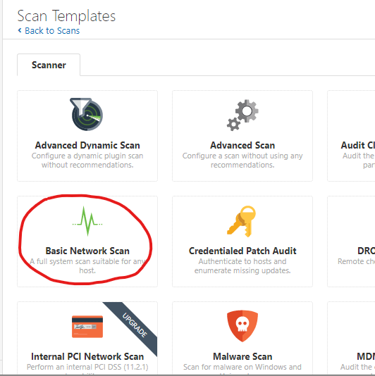

12. Fill out the areas indicated below:
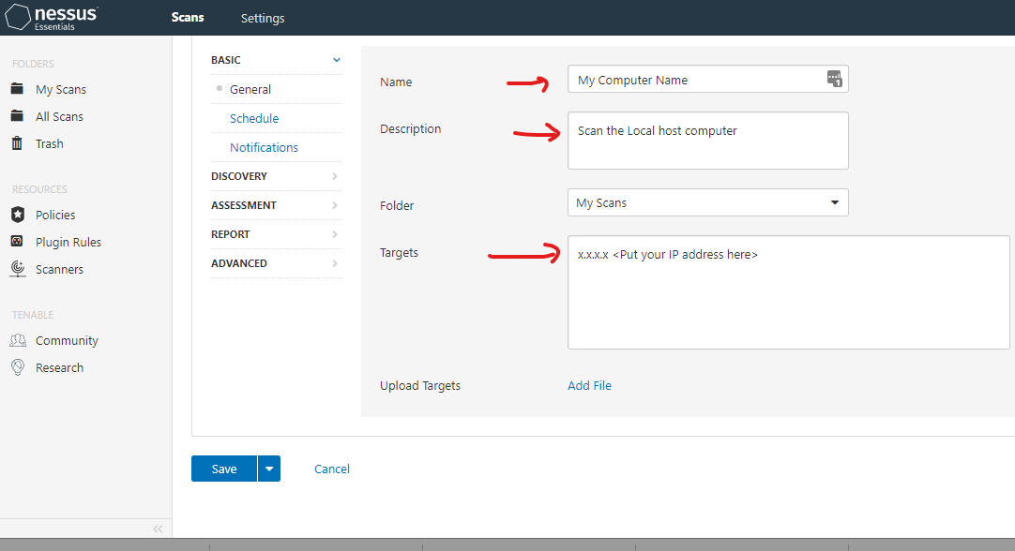

13. Then Click the Save button.
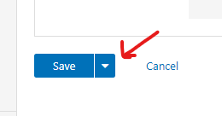
14. There will be a new scan item in the Nessus window. Select the play button to run. (This may take several minutes to complete
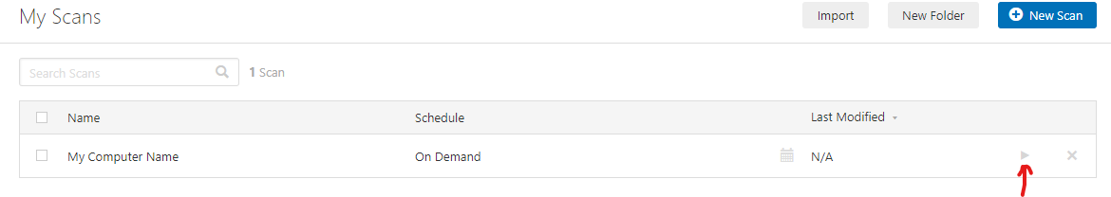

15. Once it is done, then click on the Scan job for the results.

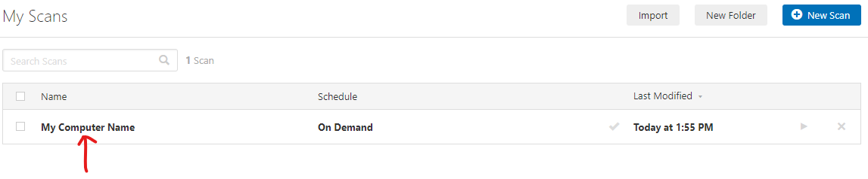
16. Select the Vulnerabilities area to view the results.
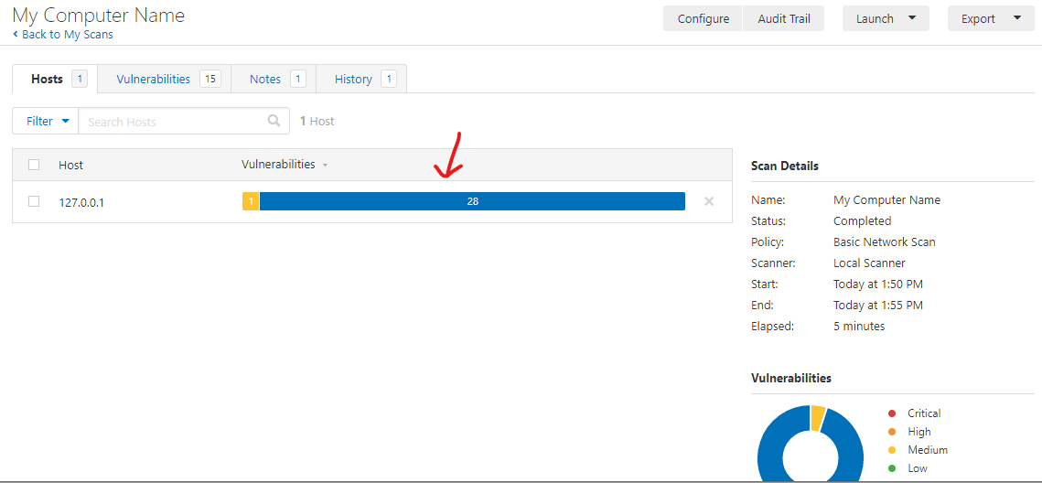
17. Select any of the results to get more info on them.
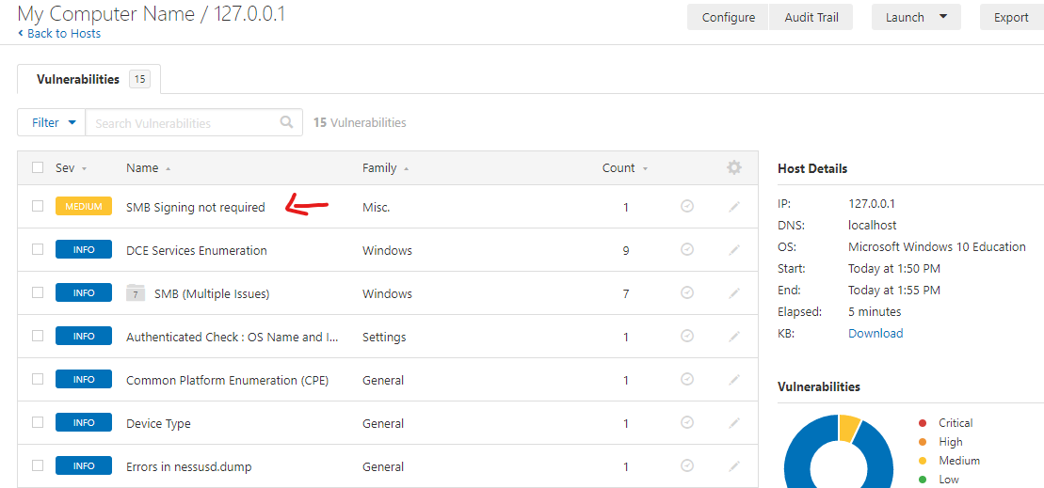
18. Take a screenshot of your results and upload them to your grade sheet deliverable.

Notes:

Week 3

Exercise 5: SQL Injection & Beyond 25

Exercise 5: SQL Injection & Beyond

Learning Objectives:
- CO 1.5 Explain different threat actors, vectors, and intelligence sources
- CO 1.6 Explain the security concerns associated with various types of vulnerabilities.
- CO 2.1 Explain the importance of security concepts in an enterprise environment.
- CO 3.1 Given a scenario, implement secure protocols.

Estimated time to Complete: 3 hours

Description:
The purpose of this lab is to gain practical experience and to build real-world network security skills with common vulnerabilities.

Required Resources:
- A working PC with Windows 10 or better installed.
- Your home network will be used.
- Active Internet Connection

Deliverable:
Answer each of the questions in this manual, then transfer your answers to the item “Week 3: Hands-on exercise 1 Grade Sheet” in Canvas.
Setup:
Login to a desktop or laptop computer running Windows 7 or above with internet access.
Lab Steps:
SQL Injection & Beyond
For this lab we will be taking a hands on approach for some of the main security vulnerabilities a hacker will employ to try to compromise our enterprise.
- Open your browser and go to: https://www.hacksplaining.com/lessons
- Here we will see fifteen different vulnerabilities that each have a exploit we can inject/infect etc.
Your deliverable for this weeks lab is to complete any ten vulnerabilities (one MUST be SQL Injection and 9 others of your choice) and complete the exercise associated with them and take a screenshot of your final screen of the lab for each of the ten labs.
Example:
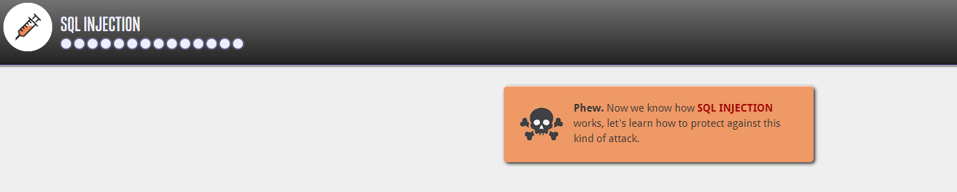
Be sure to take your time on these and read the follow-up screen on how to prevent against this. This information will be invaluable when it comes to the Security +

When done upload all ten of your screenshots completed lab to Week 2: Hands-On Exercise 1: SQL Injection & Beyond in Canvas to receive full credit for this week’s lab.
Notes:

Week 4

Exercise 7: Authenticating Authentications 29
Exercise 8: Password Policy & DAC 35

Exercise 6: Authenticating Authentications

Learning Objectives:
- CO 2.1 Explain the importance of security concepts in an enterprise environment
- CO 2.4 Summarize authentication and authorization design concepts
- CO 3.3 Given a scenario, implement secure network designs
- CO 3.7 Given a scenario, implement identity and account management controls.
- CO 3.8 Given a scenario, implement authentication and authorization solutions.
Estimated time to Complete: 1 hour 30 minutes

Description:
The purpose of this lab is to gain practical experience and to build real-world authentication skills with the five CompTIA factors of authentication.

Required Resources:
- A working PC with Windows 10 or better installed.
- Your home network will be used.
- Active Internet Connection

Deliverable:
Answer each of the questions in this manual, then transfer your answers to the item “Week 4: Hands-on exercise 1 Authenticating Authentications Grade Sheet” in Canvas.

Setup:
Login to a desktop or laptop computer running Windows 7 or above with internet access.

Lab Steps:
Authenticating Authentications
For this lab we will be taking a hands-on approach at understanding the theory behind the
different ways to authenticate we learned about in lecture.
- Navigate to https://medium.com/@renansdias/the-5-factors-of-authentication-bcb79d354c13
This is a more in depth look at the five differing types of authentication factors we use in cybersecurity from Renan Dias a well known security engineer. Read Renan’s thoughts on the five factors of authentication then answer the questions and scenarios below to test your knowledge and comprehension of how authentication factors work.
Q1: What type of authentication factor is your username/login ID, explain your answer.
- Record your results
____________________________________________________________
Q2: Give an example of dual factor authentication and explain why it is dual factor.
- Record your results
____________________________________________________________
Q3: Scenario: The CFO approaches you and says the new security rollout requires triple factor authentication to get into the server room. They have priced out some different ways to do this and asked for your approval on their current plan: A mantrap that requires a username and password, retinal scan, and thumbprint scan. Would you recommend this rollout or suggest not? If so why, if not what changes would you make and why?
- Record your results
____________________________________________________________

Next, we will talk about physical security. NIST (National Institute of Standards and Technology) places controls into three different groups as defined into Special Publication 800-12: Management, Operational, and Technical. CompTIA further expands these into six separate overlapping categories: Deterrent, Preventive, Detective, Compensating, Technical, and Administrative.

Deterrent
A deterrent control is anything intended to warn a would-be attacker that they should not attack. This could be a posted warning notice that they will be prosecuted to the fullest extent of the law, locks on doors, barricades, lighting, or anything can delay or discourage an attack.

Preventive
As the name implies, the purpose of preventive controls is to stop something from happening. These can include locked doors that keep intruders out, user training on potential harm (to keep them vigilant and alert), or even biometric devices and guards that deny access until authentication has occurred

Detective
The purpose of a detective control is to uncover a violation. The only time that they would be relevant is when a preventive control has failed, and they need to sound an alarm. A detective control can range from a checksum on a downloaded file, an alarm that sounds when a door has been pried open, or an anti-virus scanner that actively looks for problems. It could also be a sonic detector, motion sensor, or anything that would detect that an intrusion is underway.

Compensating
Compensating controls are backup controls that come into play only when other controls have failed. An office building may have a complex electronic lock on the door (preventive control) and a sign that you will be arrested if you enter (deterrent control), but it is a safe bet they will also have an alarm that sounds (a compensating control) when the door is jimmied as well as a backup generator (another compensating control) to keep that electronic lock active when the power goes out.

Technical
Technical controls are those controls implemented through technology. They may be deterrent, preventive, detective, or compensating (but not administrative), and include such things as firewalls, IDS, IPS, and such.

Administrative
An administrative control is one that comes down through policies, procedures, and guidelines. An example of an administrative control is the escalation procedure to be used in the event of a break-in; who is notified first, who is called second, and so on. Another example of an administrative control is the list of steps to be followed when a key employee is terminated: disable their account, change the server password, and so forth.

Given the previous information answer the following scenario:
Q4: Scenario: Your CEO approaches you and asks you to come up with a proposal for security for a new campus that your enterprise is expanding into. They want a combination of six security controls, with no more than four of them coming from the same category between technical or administrative. Create a list of the six controls you would recommend with a statement about why you would recommend them and how they mesh with each other to create a comprehensive and secure environment.
- Record your results
____________________________________________________________

Notes:

Exercise 7: Password Policy & DAC

Learning Objectives:
- CO 2.1 Explain the importance of security concepts in an enterprise environment
- CO 2.4 Summarize authentication and authorization design concepts
- CO 3.3 Given a scenario, implement secure network designs
- CO 3.7 Given a scenario, implement identity and account management controls.
- CO 3.8 Given a scenario, implement authentication and authorization solutions.
Estimated time to Complete: 1 hour 30 minutes

Description:
The purpose of this lab is to gain practical experience and to build real-world access control management skills with hands on editing of security policies and access controls.

Required Resources:
- A working PC with Windows 10 or better installed.
- Your home network will be used.
- Active Internet Connection

Deliverable:
Answer each of the questions in this manual, then transfer your answers to the item “Week 5: Hands-on exercise 2 Grade Sheet” in Canvas.

Setup:
Login to a desktop or laptop computer running Windows 7 or above with internet access.

Lab Steps:
Password Policy & DAC
For this lab we will be taking a hands on approach at creating a password policy and gaining a
comprehensive understanding of discretionary access controls (DAC).

- First we will go to our group policy editor:
- Open Command Prompt
- Type in “gpedit” and hit enter
- This new window that opened up is our group policy editor, it allows us to make a multitude of security and auditing changes to our windows local groups. It is a good idea to familiarize yourself with this editor as making registry edits, and domain group policy edits uses a very similar interface.
- Navigate inside the local group policy editor to Local Computer Policy>Computer Configuration> Windows Settings> Security Settings> Account Policy
- Here we should see two folders by default, Password Policy and Account Lockout Policy, this is where we make the majority of the changes to our windows user logins and enforce various policies.
- List the password categories you see in each of the two folders:
- Record your results
____________________________________________________________
- Now we need to learn about what each of these policies does so we can be an informed cybersecurity expert!
Q1: For each of the policies you wrote down in the last list, explain what each of them does briefly.
- Record your results
____________________________________________________________
- Now navigate to Local Computer Policy>Computer Configuration> Windows Settings> Security Settings>Local Policies
- Navigate around the three folders inside here and find which policy I we would change if our CSO asked us to disable Guest accounts.
- Record your results
____________________________________________________________
- Finally, a theory question: If we had a password policy in place that required users to change their password every 30 days, and had it setup so that users couldn’t reuse the last 4 passwords, but while going over the audit log we see that some users when required to change their password are changing it five times back to back to back. Why do you figure they are doing this? What policy could we change to prevent this behavior?
- Record your results
____________________________________________________________

- Next we will look at a type of access control used by Windows 10 workstations by default, DAC.
- On your desktop create a new word document and name it DAC.docx (or .doc if using an older version of office)
- Right click on the document icon we just created on our desktop and click on properties
- Go to the “Security” tab
- Here we can see the groups and usernames of anyone we have given permissions over this document to.
What groups and username do you see in the top box?
- Record your results
____________________________________________________________
What permissions do you see in the Permissions box? What do you think each permission does?
- Record your results
____________________________________________________________
- Now we are going to restrict some permissions:
- Click Advanced
- Click Select a principal
- In the bottom box type in “Guest” and hit Check Names
- If we see our computer name pop up with proper naming convention that means that our group was successfully found! Now try typing in Guest2 and select Check Names. We get an error message letting us know Windows can’t find that group.
- Enter “Guest” again and hit Check Names
- Click OK
- Under Type: change the entry to Deny then only select the Write checkbox and click OK
- Click Show Advanced Permissions
- Now click the Delete permission and click OK
What changed in our permissions box?
- Record your results
____________________________________________________________
What do you think this change we did does to the file we created?
- Record your results
____________________________________________________________
Feel free to delete the DAC.doc(x) document now to leave your computer the way we found it.

Week 5

Exercise 9: Mobile Device Hardening (for Android) 41
Exercise 9: Mobile Device Hardening (for Apple iOS) 57
Exercise 10: Hardening the host 72

Exercise 8: Mobile Device Hardening (for Android)
Learning Objectives:
- CO 3.5 Given a scenario, implement secure mobile solutions.
Estimated time to Complete: 1 hour 30 minutes
Description:
The purpose of this lab is to gain practical experience in hardening a mobile device. Download whichever lab file applies to your phone, complete it and upload it into the grade sheet.
Required Resources:
- A working mobile device running an android OS.
Deliverable:
Take screenshots of each security setting and embed in a word document, then upload your answers to the item “Week 1: Hands-on exercise 1 Grade Sheet” in Canvas.

Setup:
A mobile phone running Apples iOS that is open to the home screen and ready to access.

Lab Steps:

Step | √ | To Do
 |  | Basic Security
1 |  | Update operating system to the latest version
2 |  | Do not Root the device
3 |  | Do not install applications from third party app stores
4 |  | Enable device encryption
5 |  | Disable ‘Developer Actions’
6 |  | Use an application/service to provide remote wipe functionality
7 |  | Enable Android Device Manager
8 |  | Erase all data before return, repair, or recycle
 |  | Authentication Security
9 |  | Set a PIN and automatically lock the device when it sleeps
10 |  | Set an alphanumeric password
11 |  | Set Auto-Lock Timeout
12 |  | Disable ‘Make Passwords Visible’
13 |  | Erase data upon excessive passcode failures
 |  | Browser Security
14 |  | Show security warnings for visited sites
15 |  | Disable ‘Form Auto-Fill’
16 |  | Do not automatically remember passwords
17 |  | Disable browser plug-ins
18 |  | Turn on Do Not Track
 |  | Network Security
19 |  | Turn off Bluetooth when not in use
20 |  | Disable network notification
21 |  | Forget Wi-Fi networks to prevent automatic rejoin
 |  | Additional Security Settings¹
22 |  | Turn off Location Services
23 |  | Use a third party application to password protect applications with sensitive data
24 |  | Limit the number of text (SMS) and multimedia messages (MMS) saved
25 |  | Disallow cookies in Chrome browser
26 |  | Disable JavaScript in Chrome browser
27 |  | Use TextSecure to encrypt SMS messages
FOOTNOTE
¹These security settings are proactive in nature but are intended for devices where there exists a very high need for security, as they may negatively impact the user experience and interfere with the functionality and utility of many applications.
Lab Steps:
UT NOTE: ADDENDUM
This list provides specific tasks related to the computing environment at The University of Texas at Austin.
Please be aware that the exact process for activating security features will vary from device to device and between versions of the operating system. The instructions here are provided for reference only and will not be applicable to all handsets. It is recommended that users follow the instructions contained in the operating manual for their device where possible.
UT Note: Addendum
1 | Update operating system to the latest version  Android devices ship with various versions of the operating system, determined by both the selected carrier and handset manufacturer. New versions of the Android operating system frequently address security vulnerabilities in addition to providing bug fixes and adding new features. Not all devices will support the most recent version of Android and not all carriers will make upgrades available for all handsets, even ones that are capable of running the newer software. Upgrade to the latest available and supported version for your device.  For high security environments, plan on replacing devices every 2-3 years in order to stay current on operating system releases. Additionally, consider using only Nexus devices, which are supported by Google directly instead of a mobile carrier, in order to ensure that operating system updates are actually made available to you.
2 | Do not Root the device  Rooting an Android device often takes advantage of known vulnerabilities in the operating system to disable the security controls that prevent users and applications from performing actions such as executing privileged commands, interacting with the hardware at a low level, modifying and deleting necessary system files, and removing carrier and manufacturer installed applications, for example. Once these security controls are bypassed, any application has the ability to break out of its sandbox and act maliciously (perhaps unintentionally). Installers for rooting Android devices typically add a Superuser application which is used to specify the applications that have the ability to elevate their privileges, however this is another security control that must be managed and monitored by the end user. Unlike iOS devices, rooting is not required to sideload applications.  You should understand that by rooting your device, you are taking on increased responsibility for securing your device and protecting yourself from malicious software.Devices used with Category I data should not be rooted.
3 | Do not install applications from third party app stores  Google manages applications distributed through the Google Play store and has the ability to remove malicious applications both from the store when discovered and directly from any devices that have installed the applications from the Google Play store. Installing applications from other sources is riskier since you have no way of knowing how the stores are managed and whether or not the applications available in it can be trusted to not be malicious in nature.  To disable application installation from unknown sources:  - Press the Menu button  - Tap System settings.  - Tap Security.  - Scroll to Device administration.  - Uncheck Unknown sources.
4 | Enable device encryption  When enabled, Android uses your passcode or password to generate an encryption key that is then used to encrypt the device. This passcode/password is then required every time the device is powered on. This protects the data stored on the device from unauthorized access in the event that it is lost or stolen. The encryption process may take an extended amount of time, depending upon the amount of storage in the device. The device needs to remain plugged in and the encryption process should not be interrupted.  To encrypt a device:  - Press the Menu button.  - Tap System settings.  - Scroll to Personal.  - Tap Security.  - Scroll to Encryption.  - Tap Encrypt {{device}}.  - Tap Encrypt {{device}} again.  - Enter lock screen passcode or password when prompted.  - Tap Continue.  - Tap Encrypt {{device}}.
5 | Disable ‘Developer Options’  Android provides a number of features that allow developers to interact with the device through the built-in USB power/data port to change its behavior, read and modify local storage, and issue commands. When enabled, it is possible to completely control a device through this interface. These features should be enabled only as needed and only for the duration required for testing.  To disable developer options:  - Press the Menu button.  - Tap System settings.  - Scroll to System.  - Tap Developer options.  - Uncheck USB debugging.  - Uncheck Stay awake.  - Uncheck Mock locations.
6 | Use an application/service to provide remote wipe functionality  The intent with this is to ensure that if the device is lost, the data can be erased remotely. There are a couple of ways to accomplish this with Android:  - Austin Exchange Messaging Service provides this functionality to synchronized devices. Device wipes can be requested by the Exchange server administrator or initiated by the account holder through Outlook Web Access under Options > Mobile Devices.  - Google Play provides this functionality through the free Android Device Manager service.  - Many third party applications provide this functionality. Some options include Norton Mobile Security, Wave Secure, Lookout, Security Shield, and Theft Aware. The exact feature set of each application varies; some do much more than just provide remote wipe functionality. At a minimum, users should look for the ability to lock the device remotely, wipe the device remotely, and wipe the device after too many failed unlock attempts when evaluating products for this requirement.
7 | Enable Android Device Manager  Android Device Manager is a free service provided by Google that allows users to track and remotely lock or erase an Android device. A free Google account is required to use this service. If a device is lost or stolen, having this service enabled may allow the owner to find and recover the device with the assistance of the University Police Department (UTPD). Even if recovery of the device isn’t possible, the ability to remotely erase may protect any sensitive data that was stored on it.  To enable Android Device Manager:  - Press the Menu button.  - Tap System settings.  - Tap Security.  - Scroll to Device administration.  - Tap Device administrators.  - Check Android Device Manager.  - Tap Activate.
8 | Erase all data before return, repair, or recycle  In order to prevent an unauthorized person from being able to recover sensitive information from the device, the disk should be erased before it is out of your physical control. Note that for this method of erasing a device to be secure, meaning that the data is not forensically recoverable, encryption may need to be enabled on the device first (see control 4 above). This will vary based upon the specific device.  To erase a device:  - Press the Menu button.  - Tap System settings.  - Scroll to Personal.  - Tap Backup & reset.  - Tap Factory data reset.  - Check “Erase SD card” unless the SD card will be disposed of separately from the device.  - Tap Reset phone.  - Enter the passcode if requested.  - Tap Next.  - Tap Erase everything.
9 | Set a PIN and automatically lock the device when it sleeps  Setting a PIN prevents casual unauthorized access to a device. A PIN (or a password) is more secure than a pattern as patterns can be trivially observed by people around you and there have been cases of using the fingerprint smudges on devices to derive lock-screen patterns. While setting a PIN you can also configure the device to immediately require that you enter the PIN after the device sleeps. This will prevent the device from being unlocked after sleeping from inactivity without entering the PIN first. Since a 4 digit PIN only has a maximum of 10,000 possible combinations, we recommend that users select a longer PIN.  To set a PIN:  - Press the Menu button.  - Tap System settings.  - Scroll to Personal.  - Tap Security.  - Tap Screen lock.  - Tap PIN.  - Tap in a PIN.  - Tap Continue.  - Enter the same PIN again.  - Tap OK.  - Tap Automatically lock.  - Tap Immediately.  - Check Power button instantly locks if not already checked.
10 | Set an alphanumeric password  In addition to the PIN and pattern options for authentication, Android also supports the use of alphanumeric password. For high security applications, it is recommended that a complex alphanumeric password be used instead of a PIN or pattern.  To enter an alphanumeric password:  - Press the Menu button.  - Tap System settings.  - Scroll to Personal.  - Tap Security.  - Tap Screen lock.  - Tap Password.  - Type in a complex password.  - Tap Continue.  - Enter the same password again.  - Tap OK.  - Tap Automatically lock.  - Select Immediately.  - Check Power button instantly locks if not already checked.
11 | Set Auto-Lock Timeout  This option automatically locks the device after it has been inactive for the specified amount of time.  To enable:  - Press the Menu button.  - Tap System settings.  - Scroll to Device.  - Tap Display.  - Tap Sleep.  - Tap 2 minutes.  - Press the Back button.  - Scroll to Personal.  - Tap Security.  - Confirm that Automatically lock is set to “2 minutes after sleep.”
12 | Disable ‘Make Passwords Visible’  This feature controls whether passwords are displayed as they are entered. Disabling this feature increases security by making it harder for people in close physical proximity to learn your passwords by observing you interact with your device.  To hide passwords as they are entered:  - Press the Menu button.  - Tap System settings.  - Tap Security.  - Uncheck Make passwords visible.
13 | Erase data upon excessive passcode failures  Refer to control 6 above. Android does not natively provide this functionality, but there are a number of third party applications, some of which were mentioned earlier, which can. Since excessive passcode failures typically indicate the device is out of your physical control, having the device automatically erase may protect the confidentiality of information stored on the device.
14 | Show security warnings for visited sites  This feature will warn you of common security problems, such as invalid or expired SSL certificates, affecting the web sites you visit. These warnings could indicate that communications between your computer and the site’s server are not secure, meaning that data sent to the site could be intercepted. Caution should be exercised when using sites that generate security warnings with this feature.  To show security warnings for sites:  - Tap the globe Browser icon.  - Press the Menu button.  - Tap Settings.  - Tap Privacy & security.  - Check Show security warnings.
15 | Disable ‘Form Auto-Fill’  Date entered into web forms may be stored so that, upon subsequent visits to the page, the form can be auto-completed. While this may be convenient, it also may result in the storage of sensitive information, such as passwords and credit card numbers, locally on the device. Additionally, automatically filling in web forms could result in the unintentional disclosure of sensitive data to unauthorized people.  To disable the ‘Form auto-fill’ functionality:  - Tap the globe Browser icon.  - Press the Menu button.  - Tap Settings.  - Tap Privacy & security.  - Scroll to Form data.  - Tap Clear form data.  - Tap OK on the confirmation dialog.  - Uncheck Remember form data.  - Press the Back button.  - Tap General.  - Uncheck Form auto-fill.
16 | Do not automatically remember passwords  Refer to control 14 above. Passwords entered into forms are automatically stored so that they can be auto-filled upon subsequent visits to the site. This not only results in the local storage of user credentials entered via the web browser, but having the browser automatically fill forms using this data may result in the unintentional disclosure of the data to a unauthorized person.  To prevent the browser from remembering passwords:  - Tap the globe Browser icon.  - Press the Menu button.  - Tap Settings.  - Tap Privacy & security.  - Scroll to Passwords.  - Tap Clear passwords and tap OK on the confirmation dialog.  - Uncheck Remember passwords.
17 | Disable browser plug-ins  Chrome supports plug-ins that allow developers more control over sites or enable richer user experiences, such as Flash. Historically, the security of such plug-ins has been very poor and they have been and remain a very commonly exploited vector for infection by malware. Plug-ins should only be enabled for trusted sites and disabled when not in use.  To disable plug-ins in Chrome:  - Tap the globe Browser icon.  - Press the Menu button.  - Tap Settings.  - Tap Advanced.  - Tap Enable plug-ins.  - Select Off.
18 | Turn on Do Not Track  The Do Not Track option instructs Chrome to send a specific header in web requests that indicates the your preference not to be tracked by the websites you visit. Many sites have opted to honor this preference so there is some small privacy benefit from enabling it. It is important to note, however, that this feature is strictly voluntary and web sites are under no obligation to honor it. There are no guarantees that any specific web site will now, or, in the future, continue to, obey this header.  To turn on Do Not Track:  - Tap the globe Browser icon.  - Press the Menu button.  - Tap Settings.  - Tap Privacy.  - Tap Do Not Track.  - Select On.
19 | Turn off Bluetooth when not in use  Disabling Bluetooth reduces the remote attack surface of devices and may also prevent you from unintentionally connecting to unknown Bluetooth services and devices. Bluetooth should be enabled only when it is actively being used.  To turn off Bluetooth:  - Press the Menu button.  - Tap System settings.  - Scroll to Wireless & networks  - Slide the Bluetooth switch to Off.
20 | Disable network notification  By default, Android devices will automatically present a list of detected wireless networks from an icon in the status bar that users may attempt to connect to when no networks that have previously been connected to are available. The issue is that anyone can run a wireless hotspot and, joining a poorly configured or insecure network could allow a malicious user on that same network to intercept, capture, and alter any network traffic sent by a user. In fact, many attackers will intentionally run wireless networks in popular, crowded areas, like airports and coffee shops, hoping to lure unsuspecting users into connecting. If this feature is disabled, you must manually search for and select a wireless network to join. This may reduce the risk of inadvertently joining a similarly named yet untrusted network (e.g. “efault” instead of “default”).  To disable network notifications:  - Press the Menu button.  - Tap System settings.  - Tap More… if present.  - Tap Wi-Fi settings.  - Tap the Menu icon and choose Advanced.  - Uncheck Network notification.
21 | Forget Wi-Fi networks to prevent automatic rejoin  By default, an Android device will remember and automatically rejoin networks that it has previously associated with. The problem with this is a trusted but unauthenticated Wi-Fi network may be spoofed and then automatically joined. Additionally, if previously joined network has a common SSID, such as “default” or “linksys”, it is very probable that the device will encounter an untrusted instance of a same-named Wi-Fi network and automatically join it.  To forget a remembered or connected Wi-Fi network:  - Press the Menu button.  - Tap System settings.  - Scroll to Wireless & networks.  - Tap More… if present.  - Tap Wi-Fi.  - In the Wi-Fi settings, locate the Wi-Fi network.  - Tap and hold down on the entry for the network you wish to forget.  - Tap Forget.
22 | Turn off Location Services  Location Services allows installed applications and visited websites the ability to request your current location. Once access is granted to an application, the application may request the data again at any time with no further notification to users.  To turn off Location Services:  - Tap globe Browser icon.  - Press the Menu button.  - Tap Settings.  - Tap Privacy & security.  - Scroll to Location.  - Uncheck “Enable location.”  - Press the Home button.  - Press the Menu button.  - Tap System settings.  - Scroll to Personal.  - Tap Location services.  - Uncheck Google’s location service.  - Uncheck GPS satellites.
23 | Use a third party application to password protect applications with sensitive data  Some options for this include App Lock, App Protector Pro, and Protector. These applications allow for a separate password to be required to launch specific applications. This may be useful to secure applications that store sensitive data so they cannot be accessed even if the device is found unlocked. If supported by your device, encryption is a much stronger and more secure approach to protecting data however (see control 4 above).
24 | Limit the number of text (SMS) and multimedia messages (MMS) saved  For high security environments, limiting the number of SMS and MMS messages saved per conversation thread may reduce the likelihood and scope of information disclosure in the event the device is lost or compromised.  To limit the number of messages saved:  - Tap Message icon.  - Press Menu button.  - Tap Settings.  - Check Delete old messages.  - Tap Text message limit.  - Scroll to 100.  - Tap Set.  - Tap Multimedia message limit.  - Scroll to 20 messages.  - Tap Set.
25 | Disallow cookies in Chrome browser  While this setting does have the beneficial effect of disallowing third party tracking cookies, it is overall not recommended for most users as cookies are heavily utilized by typical modern web applications. Using this feature selectively, though, may provide a sort of limited privacy mode in Chrome.  To disable cookies:  - Tap the globe Browser icon.  - Press the Menu button.  - Tap Settings.  - Tap Privacy & security.  - Tap Clear all cookie data.  - Tap OK.  - Uncheck “Accept cookies.”
26 | Disable JavaScript in Chrome browser  Ideally JavaScript should only be available when browsing trusted websites. In high security environments, it may make sense to disable JavaScript as a method of hardening the browser against malicious web sites. This is not recommended for most users as JavaScript is heavily utilized by typical modern web applications.  To disable JavaScript:  - Tap the globe Browser icon.  - Press the menu button.  - Tap Settings.  - Tap Advanced.  - Uncheck JavaScript.
27 | Use TextSecure to encrypt SMS messages  The application TextSecure available in the Google Play store can encrypt SMS and MMS messages in transit and at rest on the device. This helps secure your communications with others from interception and alteration. Also, just like limiting the number of messages saved (from control 24 above), this can reduce the likelihood and scope of information disclosure in the event the device is lost or compromised.

Exercise 8: Mobile Device Hardening (for Apple iOS)
Learning Objectives:
- CO 3.5 Given a scenario, implement secure mobile solutions.
Estimated time to Complete: 1 hour 30 minutes
Description:
The purpose of this lab is to gain practical experience in hardening a mobile device. Download whichever lab file applies to your phone, complete it and upload it into the grade sheet.
Required Resources:
- A working mobile device running an iOS.
Deliverable:
Take screenshots of each security setting and embed in a word document, then upload your answers to the item “Week 1: Hands-on exercise 1 Grade Sheet” in Canvas.

Setup:
A mobile phone running Apples iOS that is open to the home screen and ready to access.

Step | √ | To Do
 |  | Basic Security
1 |  | Update operating system to the latest version
2 |  | Do not Jailbreak iOS to sideload applications
3 |  | Enable Automatic Downloads of App Updates
4 |  | Enable remote wipe functionality
5 |  | Enable Find My iPhone
6 |  | Encrypt device backups through iTunes
7 |  | Erase all data before return, repair, or recycle
 |  | Authentication Security
8 |  | Require a passcode or password
9 |  | Enable TouchID with a complex password
10 |  | Set Auto-Lock Timeout
11 |  | Disable Grace Period for Screen Lock
12 |  | Erase data upon excessive passcode failures
13 |  | Enable Data Protection
 |  | Browser Security
14 |  | Enable Fraud Warning in Safari
15 |  | Disable AutoFill for sensitive information
16 |  | Block cookies from third parties
17 |  | Turn on Do Not Track
 |  | Network Security
18 |  | Turn off Ask to Join Networks
19 |  | Turn off AirDrop when not in use
20 |  | Turn off Bluetooth when not in use
21 |  | Turn off Personal Hotspot when not in use
22 |  | Forget Wi-Fi networks to prevent automatic rejoin
 |  | Additional Security Settings¹
23 |  | Turn off Location Services
24 |  | Restrict access to Location Services, Contacts, Photos, etc.
25 |  | Disable access to Control Center on Lock Screen
26 |  | Disable TouchID
27 |  | Enable Private Browsing in Mobile Safari as needed
28 |  | Disable JavaScript in Mobile Safari
FOOTNOTE
¹These security settings are proactive in nature but are intended for devices where there exists a very high need for security, as they may negatively impact the user experience and interfere with the functionality and utility of many applications.
Lab Steps:
UT NOTE: ADDENDUM
This list provides specific tasks related to the computing environment at The University of Texas at Austin.
UT Note: Addendum
1 | Update operating system to the latest version  Apple devices ship with the most current version of the operating system available when the device was manufactured, but new updates often address security vulnerabilities in addition to bug fixes and adding new features. Not all devices will support the most recent version of iOS. Upgrade to the latest supported version for your device. Instructions for updating iOS devices are at http://support.apple.com/kb/HT4623.  For high-security environments, plan on replacing devices every 2-3 years in order to stay current on operating system releases.
2 | Do not Jailbreak iOS to sideload applications  Jailbreaking takes advantage of known vulnerabilities in the operating system to bypass and disable the security controls that prevent unauthorized software from executing in iOS. While this does allow the use of software that is not available in the App Store, it also significantly weakens the overall security of the device. Apple reviews all applications in the App Store to filter out malicious and infected software. While not perfect, this approach does reduce the ability of malware to spread on un-Jailbroken devices. Unlike traditional computers, virus scanners and anti-malware applications for mobile operating systems like iOS are not bundled with the operating system and not comparable to their desktop counterparts in their ability to detect and quarantine malicious software. Thus, the so-called walled garden approach taken by Apple adds a significant layer of security and a hurdle for malware developers to overcome. Some applications are now checking for Jailbroken devices and refusing to install on them as well out of (misguided) piracy concerns.  Additionally, Jailbreaks may prevent you from upgrading to newer versions of iOS as they become available, as it takes time for the groups responsible for Jailbreaks to identify and exploit vulnerabilities in newer versions of iOS. Upgrading may mean losing your Jailbreak and the applications you've installed from other sources, but not upgrading may expose you to the security vulnerabilities that were addressed by the newer version of iOS.  You should understand that by Jailbreaking your device, you are taking on increased responsibility for securing your device and protecting yourself from malicious software. Devices used with Category I data should not be Jailbroken.
3 | Enable Automatic Downloads of App Updates  Application updates often address security vulnerabilities in addition to bug fixes and adding new features. It is recommended that applications, especially those used to interact with The internet and web-based services (e.g. Internet browsers) be updated frequently. This feature will automatically download and install application updates when they become available.  To enable:  - Tap Settings.  - Tap iTunes & App Store.  - Turn on Updates in the Automatic Downloads configuration list.
4 | Enable remote wipe functionality  The intent with this is to ensure that if the device is lost, the data can be erased remotely. There are number of ways to accomplish this with iOS:  Austin Exchange Messaging Service provides this functionality to synchronized devices. Device wipes can be requested by the Exchange server administrator or initiated by the account holder through Outlook Web Access under Options > Mobile Devices.  Apple's iCloud service provides, among other things, the ability to track GPS enabled devices, display messages on the screen, lock a device, and wipe all data. These features are provided free of charge to owners of iPhone 4 and newer, iPod Touch 4th generation and newer, and all iPad devices, but this does need to be setup on the device in advance (i.e. it can't be done after the device is lost). This feature is called Find My iPhone, which is discussed in more detail later.
5 | Enable Find My iPhone  Find My iPhone is a free service provided by Apple that allows users to track and remotely lock or erase an iDevice. Despite the name, this service also works with iPad and iPod Touch devices. A free iCloud account is required to use this service. If a device is lost or stolen, having this service enabled may allow the owner to find and recover the device with the assistance of the University Police Department (UTPD). Even if recovery of the device isn't possible, the ability to remotely erase may protect any sensitive data that was stored on it. With iOS7 Apple introduced Activation Lock, so enabling Find My iPhone now also prevents someone from erasing and restoring a device without entering the iCloud username and password associated with it.  To enable Find My iPhone:  - Tap Settings.  - Tap iCloud.  - Enter your iCloud username and password if not already configured.  - Turn on Find My iPhone.  - Tap OK.  If using iOS 8, enable Send Last Location:  - Tap Settings.  - Tap iCloud.  - Tap Find My iPhone.  - Turn on Send Last Location.
6 | Encrypt device backups through iTunes  By default, backups of devices made in iTunes are not encrypted. This may expose sensitive data if the computer is lost or compromised. Additionally, data in the backup might be used to compromise the associated iOS device.  To enable encrypted backups, connect the iOS device to the computer, open iTunes, and check "Encrypt {{devicetype}} backup" under Options. Select a strong, complex password when prompted.
7 | Erase all data before return, repair, or recycle  In order to prevent an unauthorized person from being able to recover sensitive information from the device, the disk should be overwritten via the "Erase All Content and Settings" setting before it is out of your physical control.  To securely erase a device:  - Tap Settings.  - Tap General.  - Tap Reset.  - Tap Erase All Contents and Settings.  - If a passcode is configured, enter the passcode when prompted.
8 | Require a passcode or password  Setting a passcode prevents casual unauthorized access to a device. A passcode is also required in order to enable Data Protection and take full advantage of the encrypted storage of all recent iOS devices.  To configure a passcode:  - Tap Settings.  - Tap General.  - Tap Passcode Lock.  - Tap Turn Passcode On  - Enter a passcode and then tap Next  - Enter the same passcode and tap Next again.  In addition to the default 4 digit passcode, Apple also supports the use of numeric passcodes greater than 4 digits and regular alphanumeric passwords. There have been examples of brute force attacks against passcodes that bypass the normal user log in mechanisms and attack the keychain directly to prevent data from being erased after 10 invalid attempts (which is the default behavior). Since a 4 digit passcode only has a maximum of 10,000 possible combinations, we recommend that users select a longer passcode or a password when possible. iOS will present the standard numeric keypad for entry regardless of the length of a passcode, so long as the passcode consists only of numbers. For high-security applications, it is recommended that a standard alphanumeric password be used instead of a passcode.  To configure a complex passcode or password:  - Tap Settings.  - Tap General.  - Tap Passcode Lock.  - Enter the current passcode if configured.  - Turn off Simple Passcode.  - Enter current passcode when prompted.  - Enter a new, longer passcode or a password and tap Next.  - Enter the new passcode or password again and tap Next.
9 | Enable TouchID with a complex password  If the device supports TouchID (iPhone 5S and newer), configure a complex password (8 characters minimum with letters, numbers, and symbols) and enable TouchID. TouchID will allow you to authenticate to the phone without having to type in the password except when the phone is first turned on or when you have not authenticated to the phone via TouchID in more than 48 hours. Using a complex password instead of a passcode makes brute force attacks significantly harder and more time consuming, protecting the data on the phone better (the standard 4 digit passcode is defeatable in under 3 minutes). While TouchID is not perfect, this combination still represents better security than a simple passcode alone.
10 | Set auto-lock timeout  This option automatically locks the device after it has been inactive for the specified amount of time.  To enable the auto-lock timeout:  1. Tap Settings.  2. Tap General.  3. Tap Auto-Lock.  4. Tap “2 Minutes” or one of the other values. Lower values are more secure.
11 | Disable grace period for screen lock  The grace period allows the device to be unlocked after auto-locking without providing an unlock code. Setting a value of "Immediately" will require the passcode to be entered regardless of when the device was last locked.  To disable the grace period for screen lock:  1. Tap Settings.  2. Tap General.  3. Tap Passcode Lock.  4. Tap Require Passcode.  5. Tap Immediately.
12 | Erase data upon excessive passcode failures  Devices can be configured to automatically erase user settings and data after ten passcode failures. As excessive passcode failures typically indicate the device is out of your physical control, enabling this may protect the confidentiality of information stored on the device.  To enable this option:  - Tap Settings.  - Tap General.  - Tap Passcode Lock.  - Enter the current passcode when prompted and tap Done.  - Turn on Erase Data.  - Tap Enable.
13 | Enable Data Protection  With devices that support hardware encryption (iPhone 3GS and later, iPod Touch 3rd gen and later, and all iPads), iOS 4 and above allow applications to use an encryption key derived from your passcode to protect application data. Enabling this feature is as simple as setting a passcode on the device.  To verify that data protection is enabled:  1. Tap Settings.  2. Tap General.  3. Tap Passcode.  4. "Data protection is enabled" should be displayed at the bottom of the screen.  Note: If the device originally shipped with iOS 3 (e.g. the iPhone 3GS, iPad, and iPod Touch), this feature will not be available until the device is restored after upgrading to iOS 4. This feature is not available on older devices, such as the iPhone 3G and earlier models, at all, as they do not support hardware encryption.  It is important to understand that applications must be specifically designed to utilize data protection. Do not store or use sensitive data with applications that do not make use of data protection. More information regarding this feature is available on Apple's site at iOS 4: Understanding data protection.  With iOS 7 and above all third party applications and the native system apps such as Messages, Mail, Calendar, Contacts, and Photos make use of Data Protection to encrypt data.
14 | Enable Fraud Warning in Safari  The Fraudulent Website Warning feature in Safari helps protect users from visiting potentially fraudulent Internet sites. If you navigate to a known fraudulent site covered by this service, Safari will not load the site and instead display a warning about its suspect nature.  To enable:  - Tap Settings.  - Tap Safari.  - Turn on Fraudulent Website Warning.
15 | Disable AutoFill for sensitive information  AutoFill will remember information entered into forms and then automatically fill in this information in matching fields on later forms. While this may be convenient, it also may result in the storage of sensitive information locally on the device. Additionally, automatically filling in fields on web forms could result in unintentional disclosure of sensitive data to unauthorized people. It is strongly recommended that, at a minimum, the storage of Credit Cards be disabled.  To disable AutoFill:  - Tap Settings.  - Tap Safari.  - Tap Passwords & AutoFill.  - Deselect the categories of information you do not want to be saved and automatically filled in.
16 | Block cookies from third parties  Third party cookies are set by websites other than those specifically navigated to by you. These cookies are often used for tracking and may facilitate identification and behavioral analysis of users for the purposes of advertising. While third party cookies do not represent a specific security threat, they offer no benefit to end users and help erode online privacy.  To configure blocking of third party cookies:  - Tap Settings.  - Tap Safari.  - Tap Block Cookies and select "From third parties and advertisers"
17 | Turn on Do Not Track  The Do Not Track option instructs Safari to send a specific header in web requests that indicates the your preference not to be tracked by the websites you visit. Many sites have opted to honor this preference so there is some small privacy benefit from enabling it. It is important to note, however, that this feature is strictly voluntary and web sites are under no obligation to honor it. There are no guarantees that any specific web site will now, or, in the future, continue to, obey this header.  To turn on Do Not Track:  - Tap Settings.  - Tap Safari.  - Turn on Do Not Track.
18 | Turn off Ask to Join Networks  By default, iOS devices will prompt you to join an unknown network, if any are detected, when no networks that have previously been connected to are available. The issue is that anyone can run a wireless hotspot and, joining a poorly configured or insecure network could allow a malicious user on that same network to intercept, capture, and alter any network traffic sent by a user. In fact, many attackers will intentionally run wireless networks in popular, crowded areas, like airports and coffee shops, hoping to lure unsuspecting users into connecting. If this feature is disabled, you must manually select a wireless network to join from a list of detected available networks. This may reduce the risk of inadvertently joining a similarly named yet untrusted network (e.g. “defualt” instead of “default”).  To disable Ask to Join Networks:  - Tap Settings.  - Tap Wi-Fi.  - Turn off “Ask to Join Networks”.
19 | Turn off AirDrop when not in use  AirDrop is a service that provides a very simple and easy way to transfer files and information between iOS devices. As with all such services, it is safer to have it enabled only when it is actively being used and you are expecting to transfer or receive files.  To turn AirDrop off:  - Open the Control Center by swiping up from the bottom of the iOS 7 screen.  - Tap AirDrop.  - Tap Off.
20 | Turn off Bluetooth when not in use  Disabling Bluetooth reduces the remote attack surface of devices and may also prevent you from unintentionally connecting to unknown Bluetooth services and devices. Bluetooth should be enabled only when it is actively being used.  To turn off Bluetooth:  - Tap Settings.  - Tap Bluetooth.  - Turn off Bluetooth.
21 | Turn off Personal Hotspot when not in use  The Personal Hotspot feature allows devices with cellular data connections to share their network connectivity with other devices over Bluetooth, Wi-Fi, or USB. This feature should be disabled when not in use to prevent unauthorized usage and reduce the remote attack surface of the device.  To turn off Personal Hotspot:  - Tap Settings.  - Tap Cellular.  - Tap Personal Hotspot.  - Turn off Personal Hotspot.
22 | Forget Wi-Fi networks to prevent automatic rejoin  By default, an iOS device will remember and automatically rejoin networks that it has previously associated with. The problem with this is a trusted but unauthenticated Wi-Fi network may be spoofed and then automatically joined. Additionally, if previously joined network has a common SSID, such as “default” or “linksys”, it is very probable that the device will encounter an untrusted instance of a same-named Wi-Fi network and automatically join it.  To forget a remembered or connected Wi-Fi network:  - Tap Settings.  - Tap Wi-Fi.  - Locate the Wi-Fi network to forget and tap the Detail Disclosure button.  - Tap Forget this network.  - Tap Forget.  Note: the Wi-Fi network must be in range for it to appear in the list of available networks to forget; if the Wi-Fi network is no longer in range, the user must reset all network settings, which will forget all Wi-Fi networks.
23 | Turn off Location Services  Location Services allows installed applications and visited websites the ability to request your current location. Once access is granted to an application, the application may request the data again at any time with no further notification to users.  To turn off Location Services:  - Tap Settings.  - Tap Privacy.  - Tap Location Services.  - Turn off Location Services.  - Tap Turn off on the confirmation dialog.
24 | Restrict access to Location Services, Contacts, Photos, etc.  With iOS 7, application access to Location Services, Contacts, Photos, Calendars, and similar user data can all be controlled and restricted on a per application basis. Applications will prompt for access to this user data once, and afterwards changes can be made in Settings -> Privacy and selecting the specific type of information that was requested. So instead of disabling Location Services, for example, you could go to Settings -> Privacy -> Location Services and specifically choose the applications you wish to allow to access your current location. Location Services in particular is unique as this service can also be configured to place an icon in the status bar when in use as a visual notification that an app is accessing your location.  It is strongly recommended that users go through this setting and disable access to personal and confidential data from applications that have no need of it. Additionally, some forms of advertising (e.g. location based iAds) and ad tracking can be disabled and limited here.
25 | Disable access to Control Center on Lock Screen  The Control Center introduced in iOS 7 allows users to quickly access certain frequently used settings and applications without having to unlock the device. Almost immediately after the release of iOS 7, a vulnerability was found in this feature that allowed anyone with physical access to the device to bypass the lock screen and access a significant amount of potentially sensitive data on a device. While this specific flaw was fixed with iOS 7.0.2, the nature of the Control Center and the applications it grants access to both make it a valuable target for attackers. Disabling access to the Control Center from the Lock Screen could help mitigate any future bypass exploits that are found. The Control Center is still available with this setting, the device just has to be unlocked first.  To disable the Control Center from the Lock Screen:  - Tap Settings.  - Tap Control Center.  - Turn off Access on Lock Screen.
26 | Disable TouchID  On iPhone 5S and newer devices, TouchID allows a fingerprint to unlock the device in place of entering a passcode/password. While TouchID is substantially better than not having a passcode at all, the best option for high security environments is still a strong alphanumeric password. TouchID has also been bypassed, although not in a way that would make it less viable or secure for most users. Despite this, questions do remain as to what data Apple is capturing in order to facilitate TouchID and how this data is stored and accessed. As with all biometric identification schemes, users should exercise extreme caution before use, as you can't change the aspects of your person that these systems use if they turn out to be untrustworthy (that is to say, you can't change your fingerprints).  To disable TouchID:  - Tap Settings.  - Tap General.  - Tap Passcode & Fingerprint.  - Tap Fingerprint.  - Turn off Passcode Unlock for the Fingerprints setting.  - Follow the steps in control 8 above to set a complex password.  While disabling TouchID and setting a complex password is the most secure configuration, it obviously is the least usable configuration as this complex password has to be entered every time to unlock the device. TouchID combined with a complex password is more secure than a simple passcode alone, while still convenient to use. Don't disable TouchID only to use a 4 digit passcode.
27 | Enable Private Browsing in Mobile Safari as needed  Private Browsing is a mode that can be enabled in Safari that will prevent the browser from tracking your browsing history, performed searches, or use any AutoFill information. This is useful for protecting privacy and thwarting advertiser tracking. Note that this mode only persists for the selected session.  To enable Private Browser for a Safari session:  - Tap Safari.  - Tap the Safari button at the lower right of the screen.  - Tap Private.  - Select "Close All" or "Keep All" on the "Close All Pages?" dialog box.
28 | Disable JavaScript in Mobile Safari  Ideally JavaScript should only be available when browsing trusted websites. In high security environments, it may make sense to disable JavaScript as a method of hardening the browser against malicious web sites. This is not recommended for most users as JavaScript is heavily utilized by typical modern web applications.  To disable JavaScript:  - Tap Settings.  - Tap Safari.  - Tap Advanced.  - Turn off JavaScript.

Exercise 9: Hardening the host

Learning Objectives:
- CO 2.4 Summarize authentication and authorization design concepts.
- CO 3.1 Given a scenario, implement secure protocols.
- CO 3.7 Given a scenario, implement identity and account management controls.
- CO 3.8 Given a scenario, implement authentication and authorization solutions.

Estimated time to Complete: 1 hour 30 minutes
Description:
In this lab you will learn the basics of how to harden a Windows Operating System to make sure that it is secure for your network.
Required Resources:
- A working PC with Windows 10 or better installed.
- An Internet connection for update downloads.
Deliverable:
Answer each of the questions in this manual, then transfer your answers to the “Week 5 Hands on Exercise 2: Hardening the Host Grade Sheet” in Canvas.

Setup:
Acquire a working Windows 10 system.

Lab Steps:
How to Secure Your PC
1. Keep your Windows operating system up to date
Probably the most important step to do is checking for the latest security updates and patches available for your Windows operating system.
To get the security updates automatically, go to “Control Panel” and check if your automatic updating system is enabled or follow these steps:
Access the search box in your Windows operating system, type Windows Update.
Select Advanced options.
Click on Automatically download updates in case it is not already selected/turned on.
After checking for available updates for your Windows operating system, keep the automatic update turned on in order to download and install the important updates that can help protect your PC against new viruses or next-generation malware.

Q1. What benefits did we get from updating our Operating System?
______________________________________________________________________________
______________________________________________________________________________
______________________________________________________________________________
______________________________________________________________________________
______________________________________________________________________________
______________________________________________________________________________
______________________________________________________________________________
______________________________________________________________________________
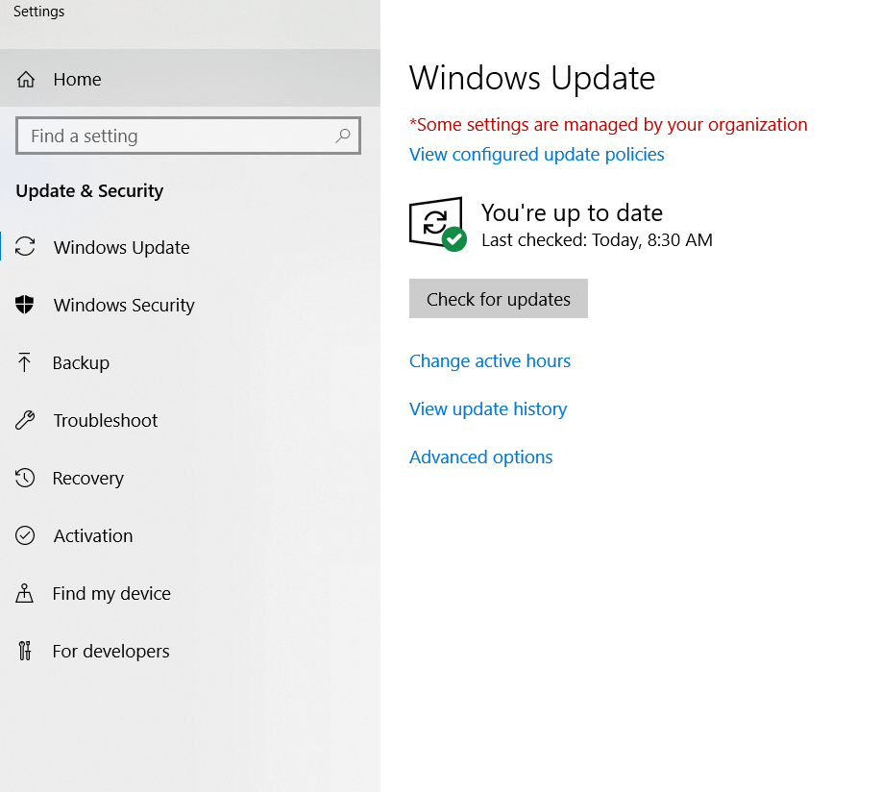

2. Update your software
You don’t have to update only the Windows operating system, but your software as well. Therefore, make sure all the latest updates and security patches for your main programs and apps are installed.
As each of the software companies release updates, they will ask for your permission to install them.
Q2. What benefits did we get from updating our software?
______________________________________________________________________________
______________________________________________________________________________
______________________________________________________________________________
______________________________________________________________________________
______________________________________________________________________________
______________________________________________________________________________
______________________________________________________________________________
______________________________________________________________________________
3. Create a restore point
If you already installed the security updates for Windows OS, the next step recommended is to create a restore point in Windows.
You can do this by clicking on the Start button, then select Control Panel > System and Maintenance (or System and Security) > System. Then select System protection and click the Create button.
After installing Windows, you can create the Restore Point and name it Clean installation, and continue installing drivers and applications.
Q3. What would be the benefit of creating a restore point? Provide at least two examples of good times to create these restore points.
______________________________________________________________________________
______________________________________________________________________________
______________________________________________________________________________
______________________________________________________________________________
______________________________________________________________________________
______________________________________________________________________________
______________________________________________________________________________
______________________________________________________________________________
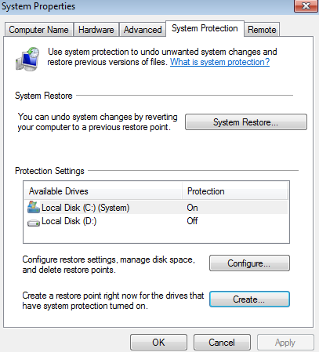
4. Install a traditional antivirus product
When you consider installing an antivirus program on your PC, make sure you use one from a legitimate company, because there can be fake software programs out there. It is important to have a reliable security solution on your system, which should include real-time scanning, automatic update, and a firewall.
If you choose to install a security product that doesn’t have a firewall, make sure you have turned on the Windows firewall.
To turn it on, go to Control Panel, select System and Security, then Windows Defender Firewall and turn it on (if it is not already).
Q4. Which anti-virus do you currently use and why? If you do not currently have one, research free anti-virus programs and explain which one you would choose and why.
______________________________________________________________________________
______________________________________________________________________________
______________________________________________________________________________
______________________________________________________________________________
______________________________________________________________________________
______________________________________________________________________________
______________________________________________________________________________
______________________________________________________________________________

5. Install an Anti-Malware Program
Financial malware especially is created to steal sensitive data and confidential information and it uses sophisticated methods to do so. Next-gen malware usually has the ability to evade detection and bypass antivirus software that users have installed on their PCs to keep their data safe.
To improve the financial control of your online banking account, you can always set banking alerts to track your account activity and apply these simple and effective financial protection tips.
Q5. Which anti-malware do you currently use and why? If you do not currently have one, research free anti-malware programs and explain which one you would choose and why.
______________________________________________________________________________
______________________________________________________________________________
______________________________________________________________________________
______________________________________________________________________________
______________________________________________________________________________
______________________________________________________________________________
______________________________________________________________________________
______________________________________________________________________________
6. Back Up Your System
You updated the operating system and your system applications, you have installed additional security products for your system safe and even created a clean installation restore point for your Windows.
The steps above are meant to keep you safe from malicious software and online threats, but you may still encounter hardware issues that could endanger your private information.
To make sure your data stays safe, you should be using a twofold strategy, which should include combining an external hard drive usage with an online backup service.
You need to understand the importance of having a backup solution which provides stability (look for a big company name), it’s easy to use (so you won’t have a headache backing up from files), allows you to synchronize your files with the online backup servers and provides some sort of security, such as encryption capabilities.
At the same time, you could simply use your Windows Backup system. To set it up, access your Windows Control Panel and then click Backup and Restore to access the location. From this place, you can set an automatic backup, create a schedule and even choose a network location for your backup files.
Q6. Why is it so important to have your files backed up in different locations? Which type of backup would you prefer to use? How often do you back up date? How often should you back up your data?
______________________________________________________________________________
______________________________________________________________________________
______________________________________________________________________________
______________________________________________________________________________
______________________________________________________________________________
______________________________________________________________________________
______________________________________________________________________________
______________________________________________________________________________
7. Use a Standard User Account
Windows provides a certain level of rights and privileges depending on what kind of user account you have. You may use a standard user account or an administrator user account.
To secure your PC, it is recommended to have a standard account to prevent users from making changes that affect everyone who uses the computer, such as deleting important Windows files necessary for the system.
With a Standard user account, you have limited rights and cannot do things like changing system settings, or installing new software apps, hardware or changing the username and passwords. Here’s why you should use an account like this one and how to create it.
If you want to install an application or make security changes, remember that you will need an administrator account.
Using a standard account ensures that a piece of malware which infects a limited-user account won’t do much damage as one infecting an administrator account.
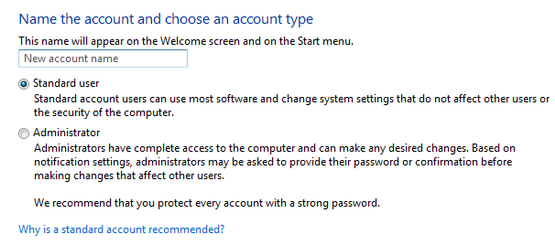
Q7. Why should you regularly use a Standard User account and why?
______________________________________________________________________________
______________________________________________________________________________
______________________________________________________________________________
______________________________________________________________________________
______________________________________________________________________________
______________________________________________________________________________
______________________________________________________________________________
______________________________________________________________________________

8. Keep Your User Account Control Enabled
User Account Control (UAC) is an essential security feature of Windows that prevents unauthorized changes to the operating system. Many users have the tendency to disable it after installing/reinstalling the Windows operating system.
UAC monitors what changes are going to be made to your computer. When important changes appear, such as installing a program or removing an application, the UAC pops up asking for an administrator-level permission.
In case your user account is infected with malware, UAC helps you by keeping suspicious programs and activities from making changes to the system.

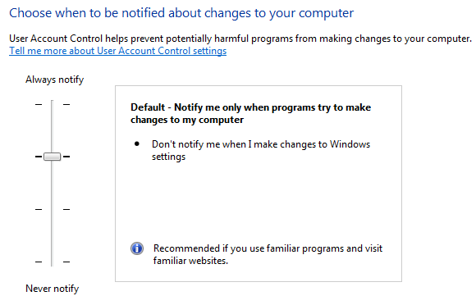
Q8. What is the purpose of UAC?
______________________________________________________________________________
______________________________________________________________________________
______________________________________________________________________________
______________________________________________________________________________
______________________________________________________________________________
______________________________________________________________________________
______________________________________________________________________________
______________________________________________________________________________
9. Secure Your Web Browser Before Going Online
Here’s another thing to do after installing Windows: pay attention to browser security. Since our web browser is the main tool used to access the Internet, it is important to keep it safe before going online.
The vulnerabilities in your web browser are like open door invitations to cybercriminals who find creative ways to harvest your most important data. For example, if you are using Adobe Flash, be aware of its security flaws and how it can expose you to attacks.
To stay safe while accessing various web pages, follow these steps:
Choose the latest version for your browser.
Keep it updated.
Choose a private browsing session when you access a website you are not sure about. Choosing this mode will prevent authentication credentials (or cookies) from being stored and steal by attackers.
Since data-stealing malware spreads through malicious code embedded in pop-up windows even in legitimate websites, make sure your web browser can block pop-ups:
- Google Chrome
- Safari
- Internet Explorer
- Mozilla Firefox
And there’s, even more, you can do. Use these step-by-step instructions to enjoy the best secure browsing.
Q9. Which browser do you prefer and why?
______________________________________________________________________________
______________________________________________________________________________
______________________________________________________________________________
______________________________________________________________________________
______________________________________________________________________________
______________________________________________________________________________
______________________________________________________________________________
______________________________________________________________________________
10. Use an Encryption Software Tool for Your Hard Drive
Even if you set a password to your Windows account, malicious actors can still get unauthorized access to your private files and documents. They can do this by simply booting into their own operating system – Linux, for example – from a special disc or USB flash drive.
A solution for this case is to encrypt your hard drive and protect all your sensitive files. It is recommended to use this level of security if you have a laptop, which can be very easily stolen. The same thing applies to a computer.
A free encryption tool you can use is BitLocker, which is available on the latest Windows operating systems and you can enable it at any moment. Even after you have enabled the BitLocker protection, you won’t notice any difference because you don’t have to insert anything else but your normal Windows user account password. The benefits of using this encryption tool:
It encrypts your entire drive, which makes it impossible for malicious actors stealing your laptop to remove the hard drive and read your files.
It’s also a great encryption software if it happens to lose your PC/laptop or get it stolen.
Easy to use and already integrated into your Windows OS, so there’s no need to add another encryption software.
If you’d rather want to use another solution, here’s a full list of encryption software tools you can choose to protect your data.
Q10. List 3 different encryption tools that you can use. Which one would you prefer?
______________________________________________________________________________
______________________________________________________________________________
______________________________________________________________________________
______________________________________________________________________________
______________________________________________________________________________
______________________________________________________________________________
______________________________________________________________________________
______________________________________________________________________________

11. Be Careful Online and Don’t Click on Suspicious Links
To make sure you won’t be infected by clicking on dangerous links, hover the mouse over the link to see if you are directed to a legitimate location. If you were supposed to reach your favorite news website, such as “www.cnn.com”, but the link indicates “hfieo88.net“, then you probably shouldn’t access it. Chances are you’ll be infected with malware and cybercriminals steal your sensitive data.
It’s worth trying shortening services, such as goo.gl or tinyurl. But in some cases, an unknown link may send you to a malicious site that can install malware on the system.
Q11. What can you do to make sure that you don’t accidentally click on a suspicious link?
______________________________________________________________________________
______________________________________________________________________________
______________________________________________________________________________
______________________________________________________________________________
______________________________________________________________________________
______________________________________________________________________________
______________________________________________________________________________
______________________________________________________________________________

Notes:

